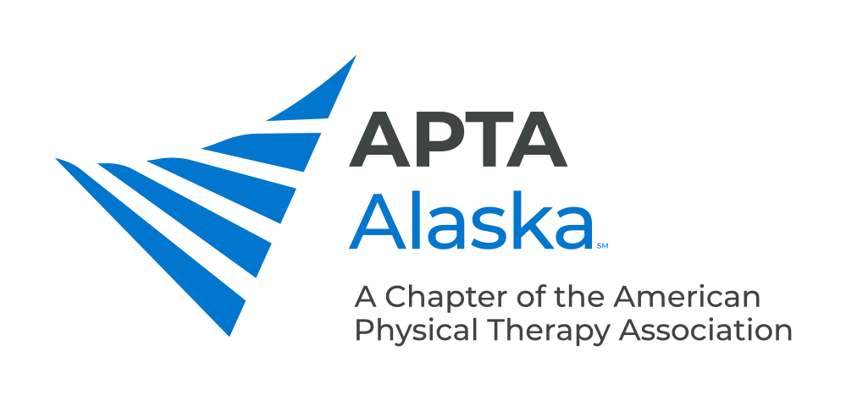

**2025 NOMINATION & INTEREST FORM**

***NOMINATION DEADLINE – SEPTEMBER 1, 2025***

***SEND NOMINATIONS TO -*** [**info@aptaalaska.org**](mailto:info@aptaalaska.org)

The following positions will be elected in the fall of 2025. Terms will begin on January 1, 2026.

Please indicate which position you are submitting a nomination for.

* **Vice President (two-year term)** (PT Members)
* **Secretary (two-year term)** (PT/PTA Members)
* **Chief Delegate (three-year term)** (PT Members)
* **Nominating Committee (three-year term)** (PT/PTA Members)

Member(s) Being Nominated: _______________________________________________________________________

Please identify the qualities that you believe this member exemplifies:

_____ Accountable/Responsible

_____ Articulate

_____ Collaborative

_____ Creative

_____ Decisive

_____ Dependable

_____ Detail-oriented

_____ Empowering

_____ Knowledgeable in Parliamentary procedures

_____ Organized

_____ Persuasive

_____ Risk taker

_____ Skilled Communicator

_____ Skilled Leader

_____ Skilled Mentor

_____ Skilled Negotiator

_____ Visionary

_____Timely in Responsiveness to Emails

Other talents and abilities this member displays that would make them a good candidate:

_________________________________________________________________________________________________

_________________________________________________________________________________________________

_________________________________________________________________________________________________

_________________________________________________________________________________________________

**If you have any questions, please contact a member of the APTA Alaska Nominating Committee:**

Kaitlin Rosales [kaitlin.freienmuth@gmail.com](mailto:kaitlin.freienmuth@gmail.com)

Savannah Winner savannahwinner18@gmail.com

Sara Montgomery [sbmont22@gmail.com](mailto:sbmont22@gmail.com)