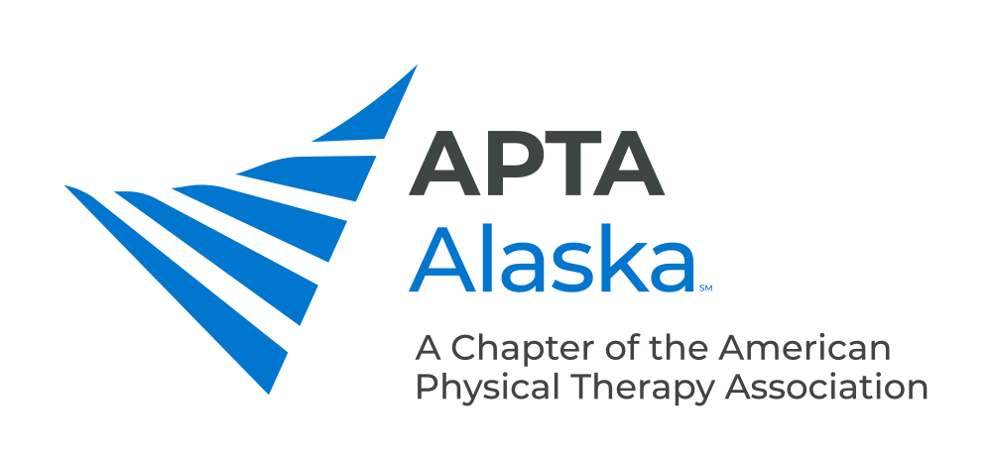

2022 NOMINATION & INTEREST FORM

NOMINATION DEADLINE – SEPTEMBER 1, 2022

SEND NOMINATIONS TO - info@aptaalaska.org

The following positions will be elected in the fall of 2022. Terms will begin on January 1, 2023.

Please indicate which position you are submitting a nomination for.

- President-Elect (one-year term as PE, Followed By a two-year term as President) PT Members
(an individual may serve as President Elect and President at the same time)
- Treasurer (two-year term) PT/PTA Members
- Chief Delegate (three-year term) PT Members
- Delegate (two-year term) PT Members
- PTA Caucus Representative (two-year term) PTA Members
- Nominating Committee (three-year term) PT/PTA Members

Member Being Nominated: _______________________________________________________________________

Please identify the qualities that you believe this member exemplifies:

_____ Accountable/Responsible
_____ Articulate
_____ Collaborative
_____ Creative
_____ Decisive
_____ Dependable
_____ Detail-oriented
_____ Empowering
_____ Knowledgeable in Parliamentary procedures

_____ Organized
_____ Persuasive
_____ Risk taker
_____ Skilled Communicator
_____ Skilled Leader
_____ Skilled Mentor
_____ Skilled Negotiator
_____ Visionary
_____Timely in Responsiveness to Emails

Other talents and abilities this member displays that would make him/her a good candidate:

_________________________________________________________________________________________________

_________________________________________________________________________________________________

_________________________________________________________________________________________________

_________________________________________________________________________________________________

If you have any questions, please contact a member of the APTA Alaska Nominating Committee:

Julie Ament - jament@northpolept.com
Ruth Carson - therapy@equinoxphysical.com
Rachel Jermann - rachel.jermann@gmail.com

