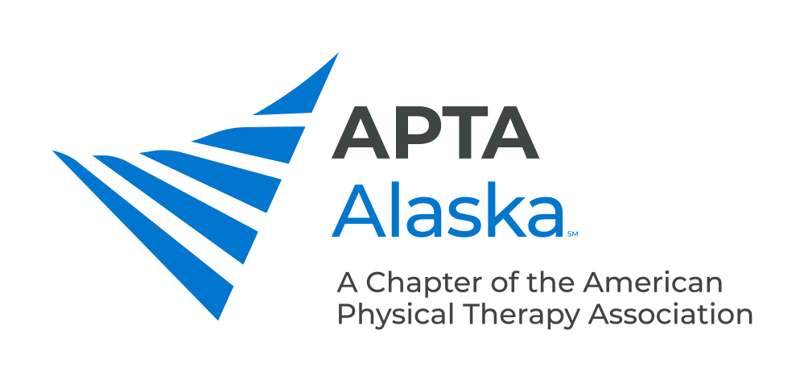

**BUSINESS MEETING**

**OCTOBER 17, 2020**

12:00 – 1:00 PM - VIRTUAL

**MINUTES**

Meeting Called to Order - 12:10 am Alec Kay, President

**CONSENT AGENDA**

Minutes – October 12, 2019

**REPORTS**

1. President Report Alec Kay, President
2. Kudos to Vice President for adapting Spring and Fall Conferences to social distancing guidelines.
3. Kudos to members, APTA Alaska, APTA for responsiveness during pandemic.
4. Kudos to LeAnne Carrothers, Pat McAdoo for their legislative action.
5. Revision of Bylaws by Bylaws Committee and Executive Director.
6. Introduction of Centennial Scholar, Rachel Jermann.
7. Developed new Vision, Mission, and Strategic Plan for our Chapter.
8. Treasurer Report Jodi Pfeiffer, Treasurer
9. Current balance $147,235, deficit of $7,041 from last year
10. Moved funds to TD Ameritrade account to general Non-Dues Revenue, working on generating other forms of Non-dues Revenue.
11. Will finalize Budget over next month.
12. PTA Caucus Report Jodi Pfeiffer, Treasurer
13. Focused on engagement of PTAs.
14. Will have monthly Facebook Live Presentations.
15. Working to increase Social Media Presence.
16. Chief Delegate Report Rebecca Byerley, Chief Delegate
17. First Virtual House of Delegates.
18. 42 motions that came forward. Items approved include:

* Use of telehealth physical therapy.
* Permit Sections to vote in the House.
* Highlight “business relations”, “collaborative relationships”, removed “Physician-owned physical therapy services.
* Committee to Review Bylaws – will review Bylaws in 2021. Overall aim is to make membership more inclusive and Bylaws less restrictive.

1. Federal and State Government Affairs Report LeeAnne Carrothers, Advocacy
2. National lobbying efforts – letters to CMS regarding fee schedule cut, telemedicine, HHS provider relief fund.
3. Practice Act bill coming back in 2021.
4. Nominating Committee Report Jill Skidmore-Erickson, Nominations
5. Current slate:

* Alec Kay – President-Elect
* Jodi Pfeiffer – Treasurer
* Patricia Beals – Delegate
* Emily Otis – PTA Caucus Rep
* Ruth Carson – Nominating Committee

1. Elections will Open October 12, 2020 and close December 3, 2020. Newly elected Officers will take office on January 1, 2021.
2. Up for election next year: Vice President, Secretary, Nominating Committee.
3. Practice & Payment Committee Report Katie Piraino, Practice & Payment
4. Email Blast will be sent out highlighting major changes.
5. Telehealth – BCBS is looking to keep Telehealth indefinitely, currently extended through 12/31, Aetna through 12/31.
6. Proposed 9% fee cut to Medicare PT services. Take action!
7. Medicare Advanced Beneficiary Notice – now have new Form on APTA website.
8. Tricare - PTAs now recognized as Providers.

* Dry Needling will not be reimbursed if it is sole purpose of visit.
* Tricare – Low Back Pain Demonstration - Beneficiaries can have 3 visits to treat Low Back Pain without any Co-Pay.

1. Evicore – Get authorization request within 7 days of evaluation.
2. 99072 – new CPT code to offset cost of practices for cleaning. BCBS and CMS will not pay for this at this time.
3. CCI edits were delayed in April. Cannot code certain CPT codes in the same visit.
4. Membership Update Rachel Jermann, Membership
5. Have had a drop to 418 members from 472 from this time last year.
6. Ideas to improve include starting PTA Special Interest Group.
7. Vote on Proposed Bylaw Amendments Meera Parekh, Secretary
8. Use Google Doc to Submit Vote. Need 10% of membership to vote, 2/3 approval to pass Amendments to Bylaws.

**NEW BUSINESS**

1. Recognition of Outgoing Board Members and Membership Anniversaries Alec Kay, President
2. Outgoing Board Members – Jodi Pfeiffer (Treasurer, on Slate for Re-election), Larry Pokladnik (PTA Caucus Representative).
3. Membership Anniversaries reviewed – Joyce Barnett and Mary Ann Paul celebrated 45 years as APTA members!
4. Call for Nominations / Committee Members Alec Kay, President
5. None Announced.

**ADJOURN** 1:24 pm