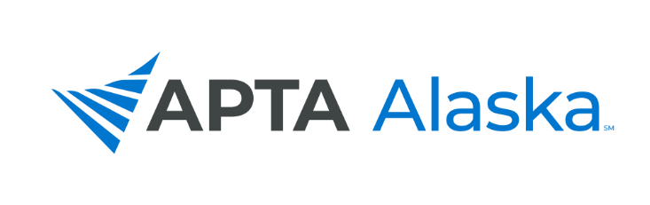
2021 VIRTUAL FALL CONFERENCE

OCTOBER 2, 2021
8:00 am – 3:30 pm
(90 Minutes of Asynchronous Work to be Completed Prior to the Conference)

A TOTAL OF 14 CONTACT HOURS

The What, When, How and Why of Oncology Rehabilitation for
Rehabilitation Professionals

Speakers: Amy J Litterini, PT, DPT and G Stephen Morris, PT, PhD, FACSM

REGISTRATION FORM

REGISTRANT INFORMATION:

Name: _________________________________________________________________________________________________

Mailing Address: ____________________________________________________________________________________

City: __________________________________________________ State: ___________ Zip: ___________________

Phone #: ___________________________________________ Designation (PT/PTA/STU/Other): _________________

E-mail: _________________________________________________ Member #: ________________________________

* REGISTRATION CONFIRMATION WILL ONLY BE SENT TO THOSE INCLUDING AN E-MAIL ADDRESS*

CONFERENCE FEES:

PT/OT/SLP Member $505
PTA/COTA/SLPA Member $455
Active Duty Military $200
Student $200
Non-Member $905

HANDOUTS AND ZOOM INFO WILL BE SENT ELECTRONICALLY THE WEEK OF THE CONFERENCE

PAYMENT – $________ (Checks should be made payable to the Alaska Physical Therapy Association)

GO TO WWW.APTAALASKA.ORG TO REGISTER AND PAY ONLINE

Cancellation Policy: Registration less $20 if cancellation request is received by September 22, 2021.

Mail registration to (must be received by Sept. 22):
APTA Alaska, 140B Purcellville Gateway Drive, Suite 120, Purcellville, VA 20132
Questions? Call 907-202-8776, or e-mail info@aptaalaska.org.

