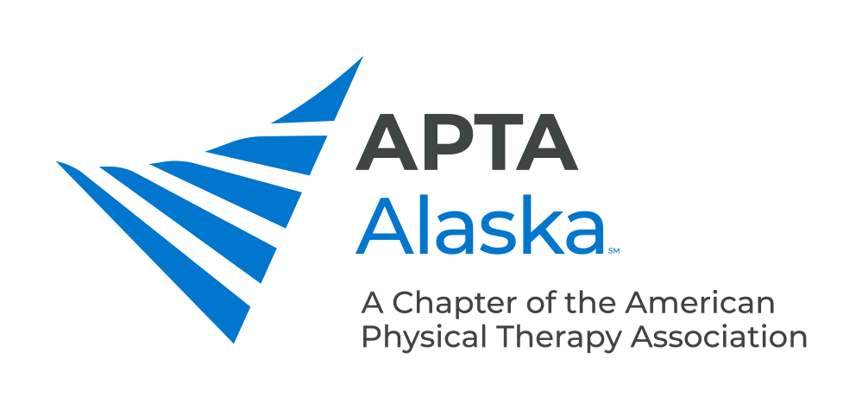

**BUSINESS MEETING MINUTES**

MARCH 16, 2021 – 7:00 PM

Meeting Called to Order and Quorum Established Kay

**CONSENT AGENDA**

1. Minutes – February 16, 2021 – Approved

**NEW BUSINESS**

1. Legislative Update Kay/Carrothers
   1. HB 99 presented to Committee on Labor and Finance
   2. Tracking HB 65 – Protects Providers from Civil Litigation in the Case of a “Curbside Consult” – Providing Counsel on whether Physical Therapists should be included in this.
   3. Considering adding joining Physical Therapy Compact to a new Bill in December.
   4. Federal – Lawmakers delayed voting on Medicare 2% cut for Reimbursement.
   5. Easy to take Action on APTA Website!
2. Spring and Fall Conference Updates Einhorn
   1. Dr. Byron Perkins – Fascial Distortion Model – Virtual Conference. Registration is open.
      1. Conference Events – Possible Hike, Outdoor Gathering Afterwards
   2. Fall Conference – Stay Tuned for Format (In-Person vs. Virtual)
3. Introduction of Regional APTA Representation Parekh
   1. Handbook Description Coming Soon.
4. Payment Update Piraino
   1. Will post update.
   2. Alaska PTs can’t do telehealth with Alaska Patients with Some Insurers.
   3. Payers will be doing Estimations of Overpayment and Eliciting Fines.
   4. APTA recommends to sign up for Electronic Funds Transfer which is a Free Option.
5. Chief Delegate Report Byerley
   1. APTA Committee to Review Bylaws – Look at Member Rights, Governance Structure.
   2. PTA Vote – PTA Vote within the House of Delegates.
6. Centennial Year Updates Kay
   1. Look for Updates on APTA Website.

**ANNOUNCEMENTS**

1. April 20, 2021 – Monthly Meeting - Gerald Omondi, Sports PT Who Works in the Kenyatta National Hospital in Nairobi, Topic: Physical Therapy in Kenya - Are our experiences that different?
2. May 1, 2021 – APTA Alaska Spring Conference - Dr. Byron Perkins will Present on: Introduction to the Fascial Distortion Model

**MEMBERS TURN TO TALK**

**ADJOURN 8:35 pm**