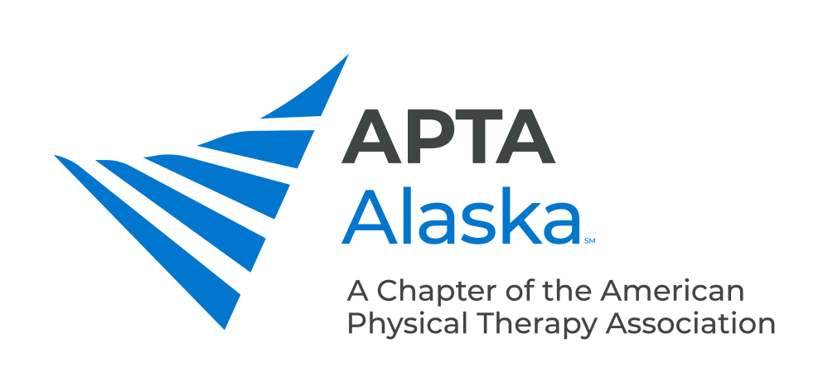

**BUSINESS MEETING MINUTES**

FEBRUARY 16, 2021 – 7:00 PM

Meeting Called to Order and Quorum Established Kay

**CONSENT AGENDA**

1. Minutes – January 19, 2021 - Accepted

**NEW BUSINESS**

1. Legislative Update Kay/Carrothers
   1. Plan to move forward with language cleanup portion of Bill, changing “Physical Therapy Assistant” to “Physical Therapist Assistant”.
   2. Approached Representatives in both House and Senate to support Bill.
   3. Looking to get Recognition within Alaska for our Centennial Celebration with a proclamation.
2. Centennial Year Update Pfeiffer
   1. Each Chapter is doing different activities.
3. Update From the Nominating Committee – Special Election Taniguchi
   1. We have two vacancies as of March 1 – PTA Caucus Representative and Treasurer.
   2. Election Opens March 26 and closes April 9.
4. CSM Update Byerley
   1. Fully online, on-demand platform through February. Still able to register. Can access all classes through end of March.
   2. Each Section has designated days.
5. Payment Chair Update Piraino
   1. Emergency Declaration Expired – Ability to perform and bill for telehealth has expired, but this is an evolving situation.
      1. Insurers must cover telemedicine services – Will send link via e-mail blast.
      2. Medicare will cover telemedicine through April.
   2. New resource on how to write defensible documentation.

**ANNOUNCEMENTS**

1. CSM 2021. The Entire Month of February, Virtual. Sign up Now
2. March16, 2021 – Monthly Meeting - Sharon Wang-Price, Speaking on LBP/Central Sensitization/Transcranial Stimulation
3. April 20, 2021 – Monthly Meeting - Gerald Omondi, Sports PT Who Works in the Kenyatta National Hospital in Nairobi, Topic TBD
4. May 1, 2021 – APTA Alaska Spring Conference - Dr. Byron Perkins will Present on: Introduction to the Fascial Distortion Model

**MEMBERS TURN TO TALK**

**ADJOURN**