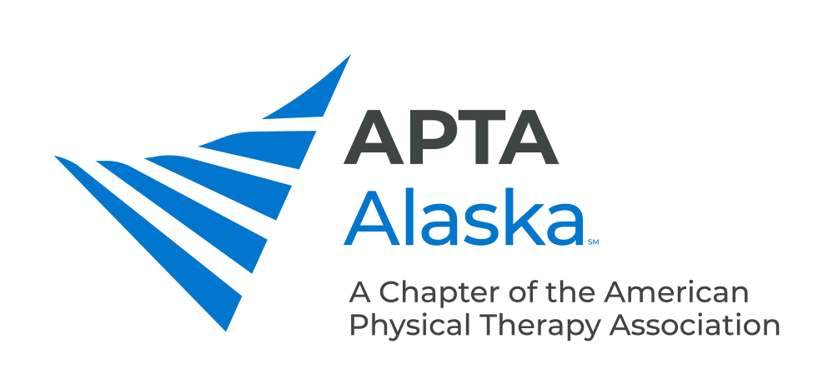

**BUSINESS MEETING MINUTES**

JANUARY 19, 2021 – 7:00 PM

Meeting Called to Order and Quorum Established Kay

**CONSENT AGENDA**

1. Minutes – November 17, 2020. Approved.

**NEW BUSINESS**

1. Legislative Update Kay/Carrothers
2. Hired new Lobbyist shared with OT and SLP Associations.
3. Moving forward with trying to get Practice Act Bill passed this year.

* Adding disciplinary action; No longer requiring English Proficiency Exam to take Boards for those trained in English-Speaking Programs; Change language to “Physical Therapist Assistants.”
* Language to join the Physical Therapy Compact Act - Increases portability of PT Licenses between States.

1. Centennial Scholar Update Jermann
2. Program started on Saturday - 100 Scholars and 25 Mentors.
3. Project: Form SIG or Committee to Facilitate Mentorship and Networking
4. PR Update Kay
5. Resume PSAs on KSKA.
6. Ideas are Welcome.
7. Bylaws Update Parekh
8. Will Recast Vote in Upcoming Special Election.
9. Call for Nominations: PTA Caucus Representative Taniguchi
10. Nominations Open for PTA Caucus Representative and Treasurer.
11. Payment Report

1. Public Health Emergency extended through the end of April - Can continue Telehealth as long as Emergency lasts.
2. Will send Bulletin via e-mail Blast with more details regarding Payment.

**ANNOUNCEMENTS**

1. CSM 2021. The Entire Month of February, Virtual. Sign up Now
2. Feb 16, 2021 – Monthly Meeting - Garret Naze: Likely Speaking on Something Related to Orofacial Pain
3. March16, 2021 – Monthly Meeting - Sharon Wang-Price, Speaking on LBP/Central Sensitization/Transcranial Stimulation
4. April 20, 2021 – Monthly Meeting - Gerald Omondi, Sports PT Who Works in the Kenyatta National Hospital in Nairobi, Topic TBD
5. May 1, 2021 – APTA Alaska Spring Conference, Dr. Byron Perkins: Introduction to the Fascial Distortion Model

**MEMBERS TURN TO TALK**

**ADJOURN**