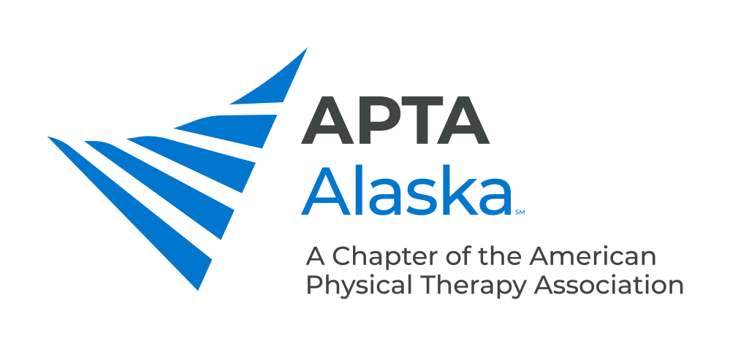

**BUSINESS MEETING MINUTES**

NOVEMBER 17, 2020 – 7:00 PM

Meeting Called to Order Kay

Quorum not Established due to <10% of members in attendance.

**CONSENT AGENDA**

1. Minutes – September 15, 2020 – Approved by Minutes Committee. Members are welcome to join Minutes Committee

**NEW BUSINESS**

1. Legislative Update Kay
   1. Will hire a new Lobbyist for 2021.
   2. Hope to pass Practice Act bill before Sunset Year 2022.
   3. Pat McAdoo and LeeAnne Carrothers – Don Young signed HB8702 – Bill in House asking for a 2-year extension for any balanced budget changes associated with Medicare cuts in services.
   4. Sen. Sullivan and Murkowski sent a letter to Senate Leadership supporting extension of current Medicare fee structure.
2. Update From Bylaws Committee Parekh
   1. Quorum was not reached for a vote, so Bylaws were not approved nor rejected.
   2. Please vote the next time this opportunity is available!
3. Member Education Opportunities Parekh
   1. MedBridge – Code AKAPTA to get discount on continuing education and patient home exercise programs
   2. California Physical Therapy Association – Discount on webinars

**ANNOUNCEMENTS**

1. Elections Open Nov. 19 and Close Dec. 3. Watch your e-mail for the link to vote.
2. Alec Kay – Ribbon cutting ceremony at new APTA building instead of dinner at steakhouse. Founder’s Day Weekend events – Mary McMillan recipient will give speech.
3. CSM 2021 will be held virtually Feb 1-28. Registration opens later this month.
4. Centennial Gala and House of Delegates in Washington DC in September.

**MEMBERS TURN TO TALK**

**ADJOURN 8:23 pm**