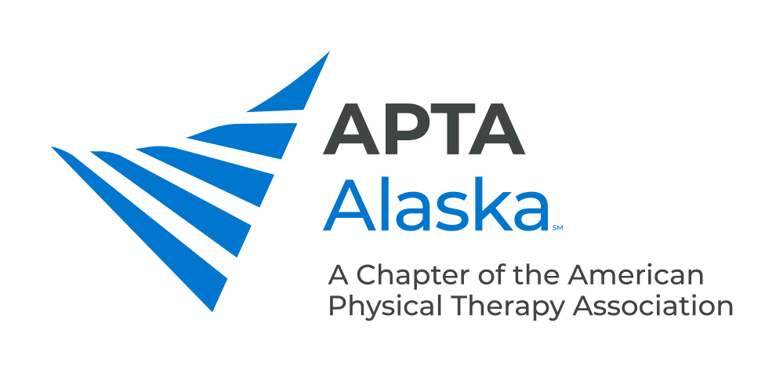

**BUSINESS MEETING MINUTES**

APRIL 21, 2020 – 7:00 PM

Meeting Called to Order and Quorum Established at 7:00 pm Kay

**CONSENT AGENDA**

1. Minutes – March 17, 2020

**NEW BUSINESS**

1. COVID-19 Kay
   1. Gov. Dunleavy’s Press Conference from this Evening – Lifting a lot of Restrictions, Restaurants can open by Friday with Restrictions, Outdoor Gatherings up to 20 people, etc.
   2. PT Practice Unchanged from Mandates on Precaution and Preparedness.
2. AKPTsHelp! Kay
   1. Movement to have PTs that would like to help in this time of need.
   2. So far 21 Members have signed up to offer Help. Looking for organizations or individuals that need assistance.
   3. Advertising – On APTA Alaska Facebook/Instagram. Other ideas: Flyers, Reach out to Organizations that already offer Assistance, send E-mails, personal social media. Looking for ideas.
3. Legislative Update Kay
   1. SB 47 was delayed in the Senate Finance Committee due to term protection of “physiotherapist”.
   2. By the time the Bill reached the House, it got put on backburner due to COVID crisis. Legislative Session is over so Bill “died” in the House.
4. Payment Update Piraino
   1. PTAs can now see Patients with Tricare. Might have problems with billing because software is not up-to-date. Recommend to contact Tricare in regards to billing.
   2. Have a PDF that has a chart for each insurer that was emailed in last update from Payment Chair. Please refer to this for billing specifics. Email katie.piraino@thephysicaltherapyplace.com.
   3. Advocacy – Form Letter on last E-mail Blast about Medicare Coverage – Take Action!
5. Update From the Licensure Board Kay
   1. Licensing Board has clarified role of PTs in Current State Mandates – see Clarification Document though Commissioner Krum and Dr. Anne Zink.
   2. Update your address with Licensing Board.
   3. Plan to Decrease Continuing Education Units Required for this Renewal Period. There will be no extension in licensure deadline. No limitation on how many Units can be obtained through Virtual Means.
6. Update From Bylaws Committee Parekh
7. Proposed Bylaw Amendments will be sent to Members at Least 30 days in advance of the

Fall Conference Business Meeting.

1. Spring Conference Update Einhorn
   1. Will have Virtual Conference on May 2 – 4-hour Conference. Registration is Open.
   2. Dr. Didrik J Soplar, PhD, LAc – “Nutrition: Improve Healing and Performance by Improving the Patient’s Immune Function”
   3. Inviting OTs, Chiropractors, colleagues out of Alaska.
2. Centennial Scholars Parekh
3. Application Deadline June 15, 2020.

**ANNOUNCEMENTS**

1. 2020 Fall Conference – Oct. 17-18, 2020 – The What, When, How and Why of Oncology Rehabilitation for Rehabilitation Professionals, Amy Litterini, PT, DPT and G Stephen Morris, PT, PhD, FACSM - Alyeska Resort, Girdwood

**MEMBERS TURN TO TALK**

**ADJOURN 8:17 pm**