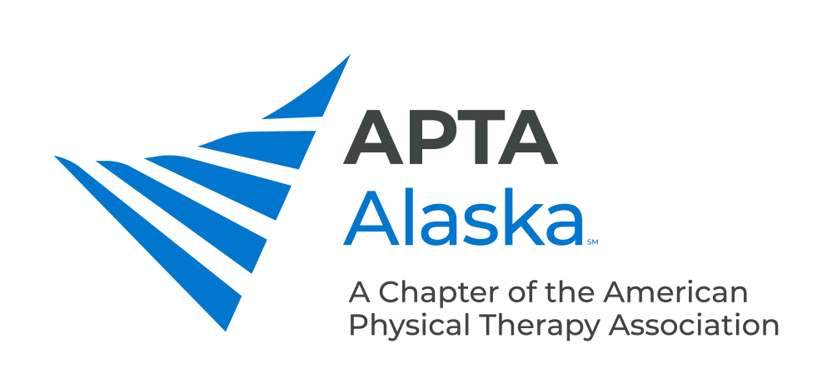

**BUSINESS MEETING MINUTES**

**MARCH 17, 2020 – 7:00 PM**

Meeting Called to Order and Quorum Established Kay

7:08 pm

**CONSENT AGENDA**

1. Minutes – February 18, 2020 - Approved

**NEW BUSINESS**

1. Coronavirus Update Kay
   1. Alec participated in a virtual town hall of component leaders with Sharon Dunn and Justin Moore.
   2. Statement from APTA – Empowering clinicians to make best practice decisions, determining whether PT is an “Essential Service”.
   3. [www.apta.org/telehealth](http://www.apta.org/telehealth)
   4. [www.apta.org/coronavirus](http://www.apta.org/coronavirus)
2. Legislative Update Carrothers
   1. SB-47 was heard today in Senate Finance, voted to move to Senate Floor.
   2. Pulled term protection for “physiotherapist” in favor to get bill passed.
   3. Caren weighed in with Senator Giessel to see if Physical Therapy can be worked into Telehealth bill.
3. Update From Bylaws Committee Parekh
   1. Cleaned up language in Bylaws and updated a lot of the Duties for Officers.
   2. Clarifying Executive Committee vs. Board of Directors – Need to clarify how PTA Caucus Representative fits into this.
   3. Defined Special Interest Groups and Districts.
   4. Outlined process for filling a vacant position on the Board.
   5. The Slate of Candidates is published 30 days in advance of the Annual Meeting and will be finalized after nominations from the floor at the Annual Meeting.
   6. Working on defining a quorum for membership meetings.
   7. Adjust time of Notice required for Special Board of Directors Meetings
   8. Next steps:
      1. Board will review/approve proposed amendments
      2. Consult with a local attorney familiar with non-profit statutes/laws
      3. Send proposed amendments to APTA Parliamentarian for review
      4. Send proposed amendments to members 30 days prior to the Annual Meeting
      5. Members will vote on the proposed amendments at the Annual Meeting
      6. Send the outcome of the vote, with the final amendments/bylaws to the APTA Parliamentarian for final review and then on to the House Officers for approval
4. Update on PSA Campaign Piraino, Backstrum
   1. Katie submitted suggestions to Shelley about phrases. 15-30 seconds aired on Alaska Public Radio.
   2. Header: Alaska Physical Therapy Association, Footer: Choose Your Own PT
5. Update From PTA Caucus Representative Pokladnik
   1. Ruling to have PTAs and OTAs able to provide care under TriCare
6. Telehealth Update Piraino, Byerley
   1. Insurers
      1. Medicare is now covering telehealth for physical therapists – see [APTA website](http://www.apta.org/telehealth) for further details
      2. Only able to see ongoing Medicare patients, called e-visits; only certain codes allowed (2061-2063); waiving HIPAA rules so you can use Skype and FaceTime; need to get verbal consent; looking into waiving registering a business to administer telehealth.
      3. Medicaid not yet covered.
      4. Aetna at Navinet – can use normal 97xxx series, use modifier for being distant.
      5. Cigna updating guidelines.
   2. Template letter to payers to encourage them to cover telehealth. Emphasize patient continuity of care.
   3. Must use place of service code for billing - 02 for telehealth.
   4. Language in Practice Act currently supports telehealth guidelines “to provide physical therapy to patients that are located at a distant site in the state…” but can also apply to those that you are not able to directly access due to risk of transmission.
   5. Katie will write a summary with links and contact names and will send out to APTA Alaska members.

**ANNOUNCEMENTS**

1. Next Monthly Meeting – April 21, 2020 – Progressive PT, Anchorage – Considering possible virtual meeting.
2. 2020 Spring Conference – May 2, 2020 – Introduction to the Fascial Distortion Model, Byron Perkins, DO - Providence Hospital, Anchorage – **Registration is Open – Early-Bird Deadline is April 4**.
3. 2020 Fall Conference – Oct. 17-18, 2020 – The What, When, How and Why of Oncology Rehabilitation for Rehabilitation Professionals, Amy Litterini, PT, DPT and G Stephen Morris, PT, PhD, FACSM - Alyeska Resort, Girdwood

**MEMBERS TURN TO TALK**

COVID-19 Update

1. Discussion of suggested procedures including contacting patients that are identified at-risk, taking precautions earlier rather than waiting for guidelines to be published.
   1. Overall best to use your clinical judgment and abide by “do no harm” principle.

**ADJOURN**

7:58 pm