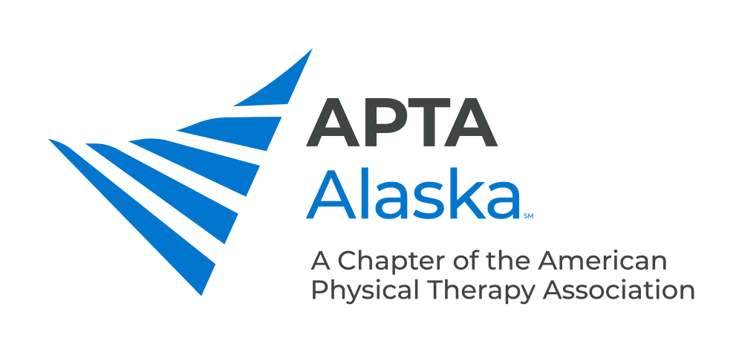

**BUSINESS MEETING**

**FEBRUARY 18, 2020**

8:00 – 8:30 pm – A Joint Effort Physical Therapy – Anchorage, AK

**MINUTES**

Meeting Called to Order and Quorum Established – 8:00 pm by Alec Kay

Special Award to Alaska Chiropractic Society Kay

**CONSENT AGENDA**

1. Minutes – January 21, 2020 Kay

**NEW BUSINESS**

1. Legislative Update Carrothers
2. Alec, Scotty Orr (OT President) and LeeAnne went to the AK Senate Labor and Commerce meeting re: SB 47, which was sent to Senate Finance.
3. Talked to Senate Labor and Finance, Labor and Commerce, House Labor and Finance – All indications were that there would be minimal pushback. Senate members asked good questions and were receptive to answers, Chiropractors were initially on board.
4. Chiropractors announced they object to term protection for “physiotherapist” (not “physiotherapy”) – Requesting line item veto.

Options:

* Send a letter that states: “sole intention is to protect term ‘physiotherapist’ and not ‘physiotherapy’”
* Strike “physiotherapist” from bill
* Fight and risk not having bill passed

1. Other PT-related items in bill:
2. Foreign-trained PTs do not have to take TOEFL if trained in an English-speaking program.
3. Utilize common language of “Physical Therapist Assistant” (vs Physical Therapy Assistant).
4. Opportunities for individuals to weigh in with senators – APTA Alaska can send out talking points, can start a PAC.
5. Update on PSA Campaign Piraino

Backstrom

1. Sent Shelly resources for AK Public Radio PSA (15-30 sec) – Phrases including “Did you know you can choose your own PT in Alaska”, “you don’t need a prescription to see a PT”, “Choose PT”, etc.
2. Update from CSM Kay
3. This year is the last year for the NEXT Conference and National Student Conclave.
4. There will be a Fall Leadership Conference in DC, starting in 2021 – Will have House of Delegates, student activities, component leadership meetings, lobbying.
5. Component Leadership Meeting – Goals to improve membership engagement and enrollment, protecting our Practice Act vs. other Practice Acts (Athletic Trainer Practice Act/Scope Expansion, etc.).
6. 2021 is Centennial Year for APTA – Founder’s Day is Jan 15, 2021. Plan to have lots of activities. Jodi Pfeiffer is Centennial Ambassador for Alaska.
7. Membership Drive/Goals Sweeney
8. Goal to get to 500 members by the end of the year (currently have 470).
9. One by One Campaign – If you recruit a member, you get entered to win a free APTA membership or conference registration, 5+ members an iPad, etc.

**ANNOUNCEMENTS**

1. Special Election Voting Closes on Feb. 21, 2020 – Please Vote - Election Results will be out Soon.
2. Next Monthly Meeting – March 17, 2020 – Juneau, AK.
3. 2020 Spring Conference – May 2, 2020 – Introduction to the Fascial Distortion Model, Byron Perkins, DO - Providence Hospital, Anchorage.
4. 2020 Fall Conference – Oct. 17-18, 2020 – The What, When, How and Why of Oncology Rehabilitation for Rehabilitation Professionals, Amy Litterini, PT, DPT and G Stephen Morris, PT, PhD, FACSM - Alyeska Resort, Girdwood.

**MEMBERS TURN TO TALK**

**ADJOURN -** 8:47 pm